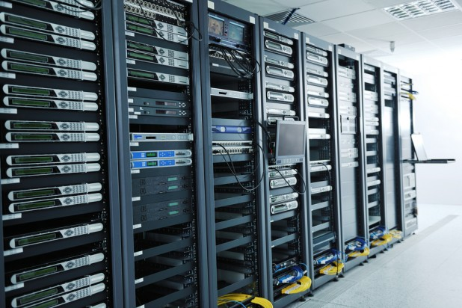



exterior Border Gateway protocol &
IS-IS Configuration Lab
Gio Hua Period 1-2

Purpose:
The objective of this lab is to configure a multi-protocol network that uses IS-IS (Integrated Intermediate System-to-Intermediate System) as the IGP (internal gateway protocol), additionally using eBGP (external border gateway protocol) for inter-AS (autonomous system) connectivity in a dual-stack (IPv4 & IPv6) environment. Some skills utilized in this lab include route redistribution from IS-IS into BGP, selective route advertisement using outbound prefix-lists toward the external AS, and proper next-hop-self handling on eBGP sessions

Background:
In modern service provider and large enterprise networks, IGPs such as IS-IS or OSPF are often utilized to provide reachability within a single autonomous system. On the other hand, BGP is used to exchange routing information with other autonomous systems and to control which prefixes are advertised outside the organization.
IS-IS is mostly used amongst large service providers due to its exceptional scalability, protocol independence, fast convergence, and natural support for both IPv4 and IPv6 using a single instance with multi-topology or single-topology mode. The IS-IS protocol was developed in the 1980s by Digital Equipment Corporation and standardized by the International Standards Organization. Routing domains can be divided into multiple subdomains. These subdomains are known as areas and have specific area addresses assigned to them. Routing within an area is referred to as Level-1 routing. Routing between Level-1 areas is known as Level-2 routing. In Open Systems Interconnection terminology, a device is referred to as an Intermediate System. An IS can operate at both Level-1 and Level-2. ISs that operate at Level 1 exchange routing information with other Level-1 ISs in the same area. ISs that operate at Level 2 exchange routing information with other Level-2 devices regardless of whether they are in the same Level-1 area. The set of Level-2 devices and the links that interconnect them form the Level-2 subdomain, which must not be partitioned in order for routing to work properly.
A key feature of BGP is its capability of controlling redistribution and selective advertisement. Internal IS-IS routes, including loopbacks, can be redistributed into BGP so they can be advertised to the outside world. However, companies typically only want to advertise very specific prefixes towards external AS(s). This selective advertisement is achieved using outbound prefix-lists.
Another key feature is next-hop-self on both iBGP and eBGP sessions. While next-hop-self is typically configured on iBGP sessions to avoid reachability problems to external next-hops, many organizations also apply it on eBGP sessions toward customers/providers when they want to hide the real entry point IP and provide a stable loopback as next-hop.
iBGP needs a full mesh or route reflectors, and next-hop-self is a crucial element when configuring. This prevents reachability issues to external next-hops inside the AS.
eBGP typically preserves the original next-hop, but in most scenarios, operators will configure next-hop-self on eBGP sessions as well.

Lab Summary:
In this lab, you configured a multi-AS, dual-stack network made up of three autonomous systems (AS 65001, AS 65002, and AS 65003) connected in a chain (R1–R2 ↔ R3–R4 ↔ R5–R6), using IS-IS Level-1 as the internal gateway protocol within each AS for both IPv4 and IPv6 reachability.
Border routers R2, R4, and R5 implement controlled external BGP peering with selective advertisement — using outbound prefix-lists to export only their own loopback addresses (2.2.2.2/32 & 2001:2::2/128 from AS 65001, 4.4.4.4/32 & 2001:4::4/128 from AS 65002, and 5.5.5.5/32 & 2001:5::5/128 from AS 65003) toward neighboring autonomous systems, while redistributing the full internal IS-IS topology into BGP.
Internal iBGP sessions (e.g., R1–R2, R3–R4, R5–R6) use next-hop-self for proper reachability, and all eBGP sessions also apply next-hop-self to present stable loopback addresses as next-hops.
Successful completion demonstrates real-world service-provider-style route control, loopback advertisement policy, dual-stack BGP configuration consistency, and hierarchical inter-AS connectivity while preventing leakage of unnecessary internal prefixes across autonomous system boundaries.

Lab Commands:

Router Configurations Explanation (Example: R2)

Global System Configuration
Command | Purpose
hostname R2 | Sets the router's host name to R2 for device identification.
ipv6 unicast-routing | Enables IPv6 forwarding, allowing the router to route IPv6 traffic.

Interface Configuration - Loopback0
Command | Purpose
interface Loopback0 | Enters Loopback interface configuration mode.
ip address 2.2.2.2 255.255.255.255 | Assigns IPv4 loopback address used for router ID stability.
ipv6 address 2001:2::2/128 | Assigns IPv6 loopback address.
ip router isis 1 | Enables IS-IS for IPv4 on this interface.
ipv6 router isis 1 | Enables IS-IS for IPv6 on this interface.

Interface Configuration - GigabitEthernet0/0/0 (R1–R2 Link)
Command | Purpose
ip address 10.0.12.2 255.255.255.0 | IPv4 address for R1-R2 link.
ipv6 address 2001:10:12::2/64 | IPv6 address for R1-R2 link.
ip router isis 1 / ipv6 router isis 1 | Enables IS-IS for IPv4 and IPv6 on this link.

Interface Configuration - GigabitEthernet0/0/1 (R2–R3 Link)
Command | Purpose
ip address 10.0.23.1 255.255.255.0 | IPv4 address for R2-R3 link.
ipv6 address 2001:10:23::1/64 | IPv6 address for R2-R3 link.
ip router isis 1 / ipv6 router isis 1 | Enables IS-IS for IPv4 and IPv6 on this link.
no shutdown | Ensures interface is active.

IS-IS Routing
Command | Purpose
router isis 1 | Creates IS-IS routing process 1.
net 49.0001.0000.0002.00 | IS-IS NET ID uniquely identifying this router.
is-type level-1 | Operates IS-IS in Level-1 mode for intra-area routing.
address-family ipv6 | Enables IPv6 routing support in IS-IS.

Prefix-Lists for Route Filtering
Command | Purpose
ip prefix-list OUT-TO-AS65002 permit 2.2.2.2/32 | Filters outbound IPv4 advertisements to AS65002.
ipv6 prefix-list OUT6-TO-AS65002 permit 2001:2::2/128 | Filters outbound IPv6 advertisements to AS65002.

BGP Configuration
Command | Purpose
router bgp 65001 | Starts BGP for AS65001.
bgp router-id 2.2.2.2 | Sets deterministic router ID using loopback.
neighbor ... remote-as | Establishes iBGP and eBGP neighbor relationships for IPv4 and IPv6.

BGP Address Family IPv4
Command | Purpose
address-family ipv4 unicast | Enters IPv4 BGP context.
neighbor ... next-hop-self | Ensures correct BGP next-hop behavior.
neighbor ... prefix-list ... out | Applies outbound IPv4 filtering.
network 10.0.12.0 mask 255.255.255.0 | Advertises local IPv4 network.
redistribute isis | Injects IS-IS routes into BGP.

BGP Address Family IPv6
Command | Purpose
address-family ipv6 unicast | Enters IPv6 BGP context.
neighbor ... activate | Activates IPv6 BGP peers.
neighbor ... next-hop-self | Ensures correct next-hop forwarding for IPv6.
neighbor ... prefix-list ... out | Applies outbound IPv6 filtering.
network 2001:2::2/128 | Advertises local IPv6 loopback.
redistribute isis | Injects IS-IS IPv6 routes into BGP.

Network Diagram:
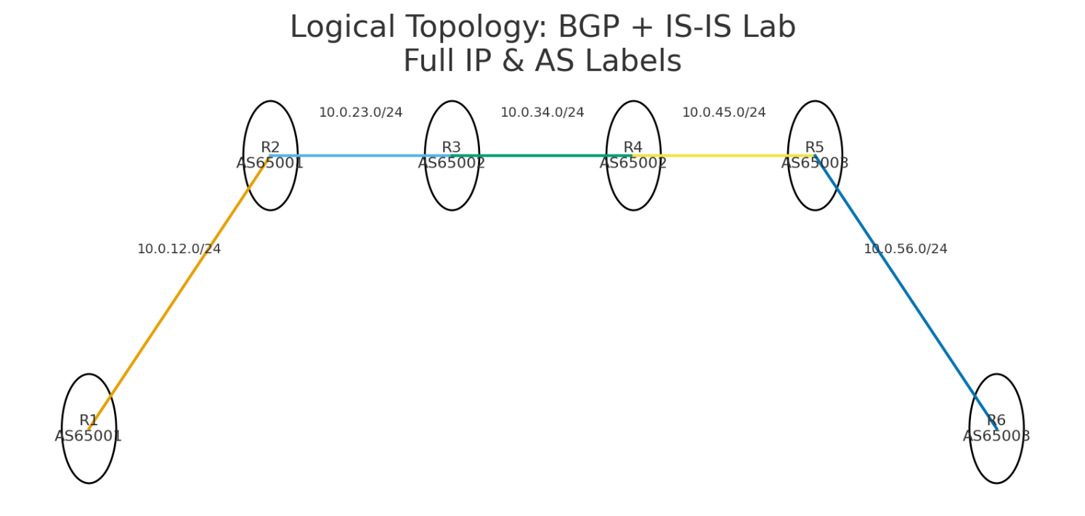

Configurations:
hostname R1
ipv6 unicast-routing
interface Loopback0
ip address 1.1.1.1 255.255.255.255
ipv6 address 2001:1::1/128
ip router isis 1
ipv6 router isis 1
interface GigabitEthernet0/0/0
ip address 10.0.12.1 255.255.255.0
ipv6 address 2001:10:12::1/64
ip router isis 1
ipv6 router isis 1
no shutdown
router isis 1
net 49.0001.0000.0001.00
is-type level-1
address-family ipv6
router bgp 65001
bgp router-id 1.1.1.1
neighbor 10.0.12.2 remote-as 65001
neighbor 2001:10:12::2 remote-as 65001
address-family ipv4 unicast
neighbor 10.0:12.2 activate
neighbor 10.0.12.2 next-hop-self
network 1.1.1.1 mask 255.255.255.255
redistribute isis
exit-address-family
address-family ipv6 unicast
neighbor 2001:10:12::2 activate
neighbor 2001:10:12::2 next-hop-self
network 2001:1::1/128
redistribute isis
exit-address-family
hostname R2
ipv6 unicast-routing
interface Loopback0
ip address 2.2.2.2 255.255.255.255
ipv6 address 2001:2::2/128
ip router isis 1
ipv6 router isis 1
interface GigabitEthernet0/0/0
ip address 10.0.12.2 255.255.255.0
ipv6 address 2001:10:12::2/64
ip router isis 1
ipv6 router isis 1
interface GigabitEthernet0/0/1
ip address 10.0.23.1 255.255.255.0
ipv6 address 2001:10:23::1/64
ip router isis 1
ipv6 router isis 1
no shutdown
router isis 1
net 49.0001.0000.0002.00
is-type level-1
address-family ipv6
ip prefix-list OUT-TO-AS65002 seq 5 permit 2.2.2.2/32
ipv6 prefix-list OUT6-TO-AS65002 seq 5 permit 2001:2::2/128
router bgp 65001
bgp router-id 2.2.2.2
neighbor 10.0.12.1 remote-as 65001
neighbor 10.0.23.2 remote-as 65002
neighbor 2001:10:12::1 remote-as 65001
neighbor 2001:10:23::2 remote-as 65002
address-family ipv4 unicast
neighbor 10.0.12.1 next-hop-self
neighbor 10.0.23.2 next-hop-self
neighbor 10.0.23.2 prefix-list OUT-TO-AS65002 out
network 10.0.12.0 mask 255.255.255.0
redistribute isis
exit-address-family
address-family ipv6 unicast
neighbor 2001:10:12::1 activate
neighbor 2001:10:23::2 activate
neighbor 2001:10:12::1 next-hop-self
neighbor 2001:10:23::2 next-hop-self
neighbor 2001:10:23::2 prefix-list OUT6-TO-AS65002 out
network 2001:2::2/128
redistribute isis
exit-address-family
hostname R3
ipv6 unicast-routing
interface Loopback0
ip address 3.3.3.3 255.255.255.255
ipv6 address 2001:3::3/128
ip router isis 1
ipv6 router isis 1
interface GigabitEthernet0/0/0
ip address 10.0.23.2 255.255.255.0
ipv6 address 2001:10:23::2/64
ip router isis 1
ipv6 router isis 1
interface GigabitEthernet0/0/1
ip address 10.0.34.1 255.255.255.0
ipv6 address 2001:10:34::1/64
ip router isis 1
ipv6 router isis 1
no shutdown
router isis 1
net 49.0002.0000.0003.00
is-type level-1
address-family ipv6
router bgp 65002
bgp router-id 3.3.3.3
neighbor 10.0.23.1 remote-as 65001
neighbor 10.0.34.2 remote-as 65002
neighbor 2001:10:23::1 remote-as 65001
neighbor 2001:10:34::2 remote-as 65002
address-family ipv4 unicast
neighbor 10.0.23.1 next-hop-self
neighbor 10.0.34.2 next-hop-self
redistribute isis
exit-address-family
address-family ipv6 unicast
neighbor 2001:10:23::1 activate
neighbor 2001:10:34::2 activate
neighbor 2001:10:23::1 next-hop-self
neighbor 2001:10:34::2 next-hop-self
network 2001:3::3/128
redistribute isis
exit-address-family
hostname R4
ipv6 unicast-routing
interface Loopback0
ip address 4.4.4.4 255.255.255.255
ipv6 address 2001:4::4/128
ip router isis 1
ipv6 router isis 1
interface GigabitEthernet0/0/0
ip address 10.0.34.2 255.255.255.0
ipv6 address 2001:10:34::2/64
ip router isis 1
ipv6 router isis 1
interface GigabitEthernet0/0/1
ip address 10.0.45.1 255.255.255.0
ipv6 address 2001:10:45::1/64
ip router isis 1
ipv6 router isis 1
no shutdown
router isis 1
net 49.0002.0000.0004.00
is-type level-1
address-family ipv6
ip prefix-list OUT-TO-AS65003 seq 5 permit 4.4.4.4/32
ipv6 prefix-list OUT6-TO-AS65003 seq 5 permit 2001:4::4/128
router bgp 65002
bgp router-id 4.4.4.4
neighbor 10.0.34.1 remote-as 65002
neighbor 10.0.45.2 remote-as 65003
neighbor 2001:10:34::1 remote-as 65002
neighbor 2001:10:45::2 remote-as 65003
address-family ipv4 unicast
neighbor 10.0.34.1 next-hop-self
neighbor 10.0.45.2 next-hop-self
neighbor 10.0.45.2 prefix-list OUT-TO-AS65003 out
redistribute isis
exit-address-family
address-family ipv6 unicast
neighbor 2001:10:34::1 activate
neighbor 2001:10:45::2 activate
neighbor 2001:10:34::1 next-hop-self
neighbor 2001:10:45::2 next-hop-self
neighbor 2001:10:45::2 prefix-list OUT6-TO-AS65003 out
network 2001:4::4/128
redistribute isis
exit-address-family
hostname R5
ipv6 unicast-routing
interface Loopback0
ip address 5.5.5.5 255.255.255.255
ipv6 address 2001:5::5/128
ip router isis 1
ipv6 router isis 1
interface GigabitEthernet0/0/0
ip address 10.0.45.2 255.255.255.0
ipv6 address 2001:10:45::2/64
ip router isis 1
ipv6 router isis 1
interface GigabitEthernet0/0/1
ip address 10.0.56.1 255.255.255.0
ipv6 address 2001:10:56::1/64
ip router isis 1
ipv6 router isis 1
no shutdown
router isis 1
net 49.0003.0000.0005.00
is-type level-1
address-family ipv6
ip prefix-list OUT-TO-AS65002 seq 5 permit 5.5.5.5/32
ipv6 prefix-list OUT6-TO-AS65002 seq 5 permit 2001:5::5/128
router bgp 65003
bgp router-id 5.5.5.5
neighbor 10.0.45.1 remote-as 65002
neighbor 10.0.56.2 remote-as 65003
neighbor 2001:10:45::1 remote-as 65002
neighbor 2001:10:56::2 remote-as 65003
address-family ipv4 unicast
neighbor 10.0.45.1 next-hop-self
neighbor 10.0.56.2 next-hop-self
neighbor 10.0.45.1 prefix-list OUT-TO-AS65002 out
redistribute isis
exit-address-family
address-family ipv6 unicast
neighbor 2001:10:45::1 activate
neighbor 2001:10:56::2 activate
neighbor 2001:10:45::1 next-hop-self
neighbor 2001:10:45::1 prefix-list OUT6-TO-AS65002 out
neighbor 2001:10:56::2 next-hop-self
network 2001:5::5/128
redistribute isis
exit-address-family
hostname R6
ipv6 unicast-routing
interface Loopback0
ip address 6.6.6.6 255.255.255.255
ipv6 address 2001:6::6/128
ip router isis 1
ipv6 router isis 1
interface GigabitEthernet0/0/0
ip address 10.0.56.2 255.255.255.0
ipv6 address 2001:10:56::2/64
ip router isis 1
ipv6 router isis 1
no shutdown
router isis 1
net 49.0003.0000.0006.00
is-type level-1
address-family ipv6
router bgp 65003
bgp router-id 6.6.6.6
neighbor 10.0.56.1 remote-as 65003
neighbor 2001:10:56::1 remote-as 65003
address-family ipv4 unicast
neighbor 10.0.56.1 next-hop-self
network 6.6.6.6 mask 255.255.255.255
redistribute isis
exit-address-family
address-family ipv6 unicast
neighbor 2001:10:56::1 activate
neighbor 2001:10:56::1 next-hop-self
network 2001:6::6/128
redistribute isis
exit-address-family
Proof of connection: all traceroutes from R1 to R6 go through
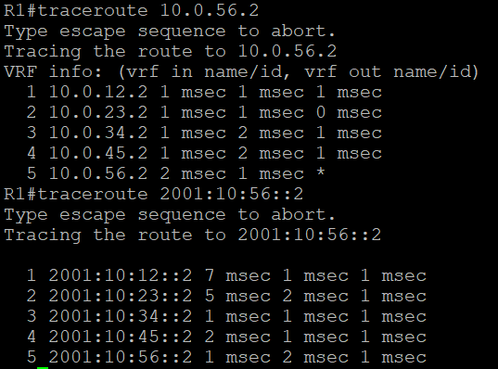
IS-IS and BGP Configuration: routes learned from ISIS are stored and BGP neighbors are visible
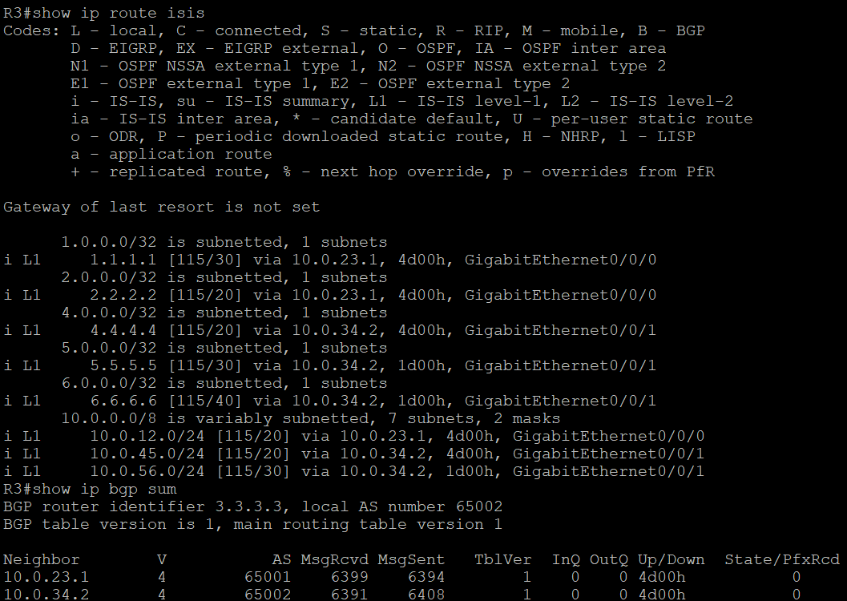
Demonstrate two features of BGP: next-hop-self & router filtering
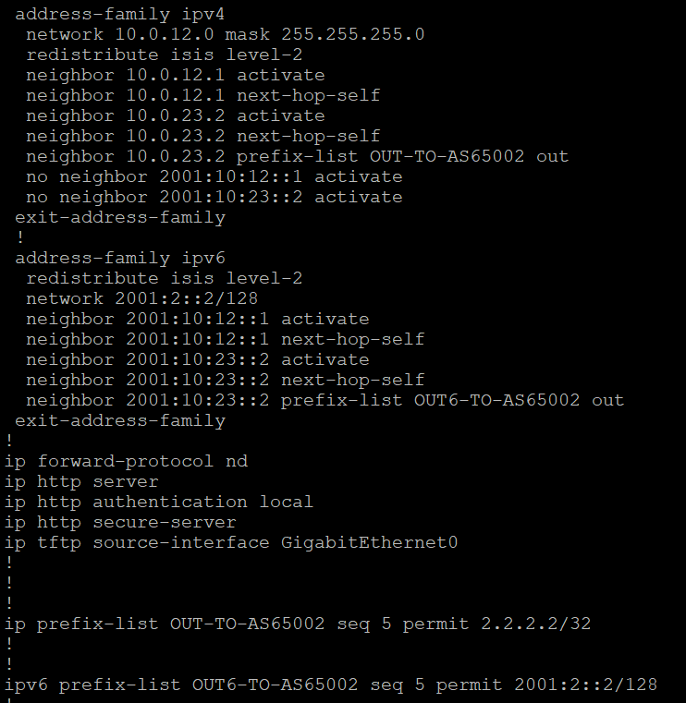
Problems:
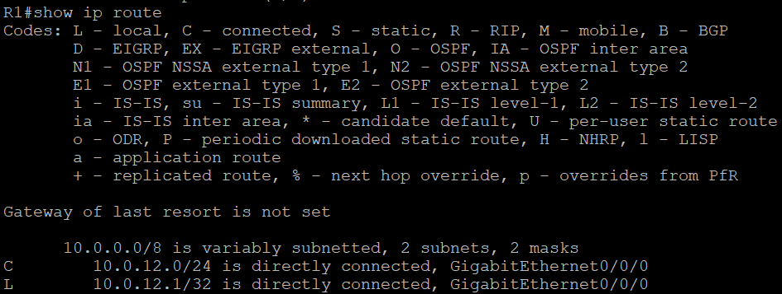
Problem – All pings went through on R6 except R1. Upon command show ip route, we can see that R1 is missing routes from redistribution
Solution – BGP wasn’t running on R1, so all I had to do was put in configurations
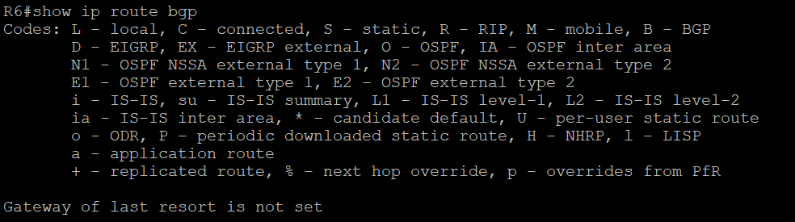
Problem – Routes are missing from the show ip route bgp command on R6. Additionally, IS-IS isn’t working between R4 & R5
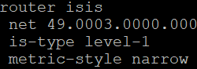
Solution – Change the command from router isis to router isis 1
Explanation - the IS-IS process tags don’t match the router isis commands on the interfaces, so IS-IS never actually comes up and IGP isn’t installing routes. Without IGP, BGP next-hops are unreachable and BGP routes remain in the BGP table, but never get installed into the RIB
no IS-IS adjacencies → no IGP routes → BGP next-hop unreachable → no RIB
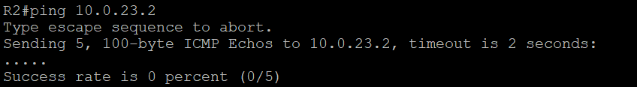
Problem – Routers don’t have routes to other routers
Solution – Set up redistribution so it links OSPF to BGP

Conclusion:
Pings and show ip route (isis or BGP) were my saving graces for this lab; anytime I needed to check connectivity, those were my go-to commands. Although I had many problems throughout this lab, most of them stemmed from improper BGP and/or IS-IS configurations. Finding the source of these problems was especially difficult due to the numerous possibilities.

